Edge

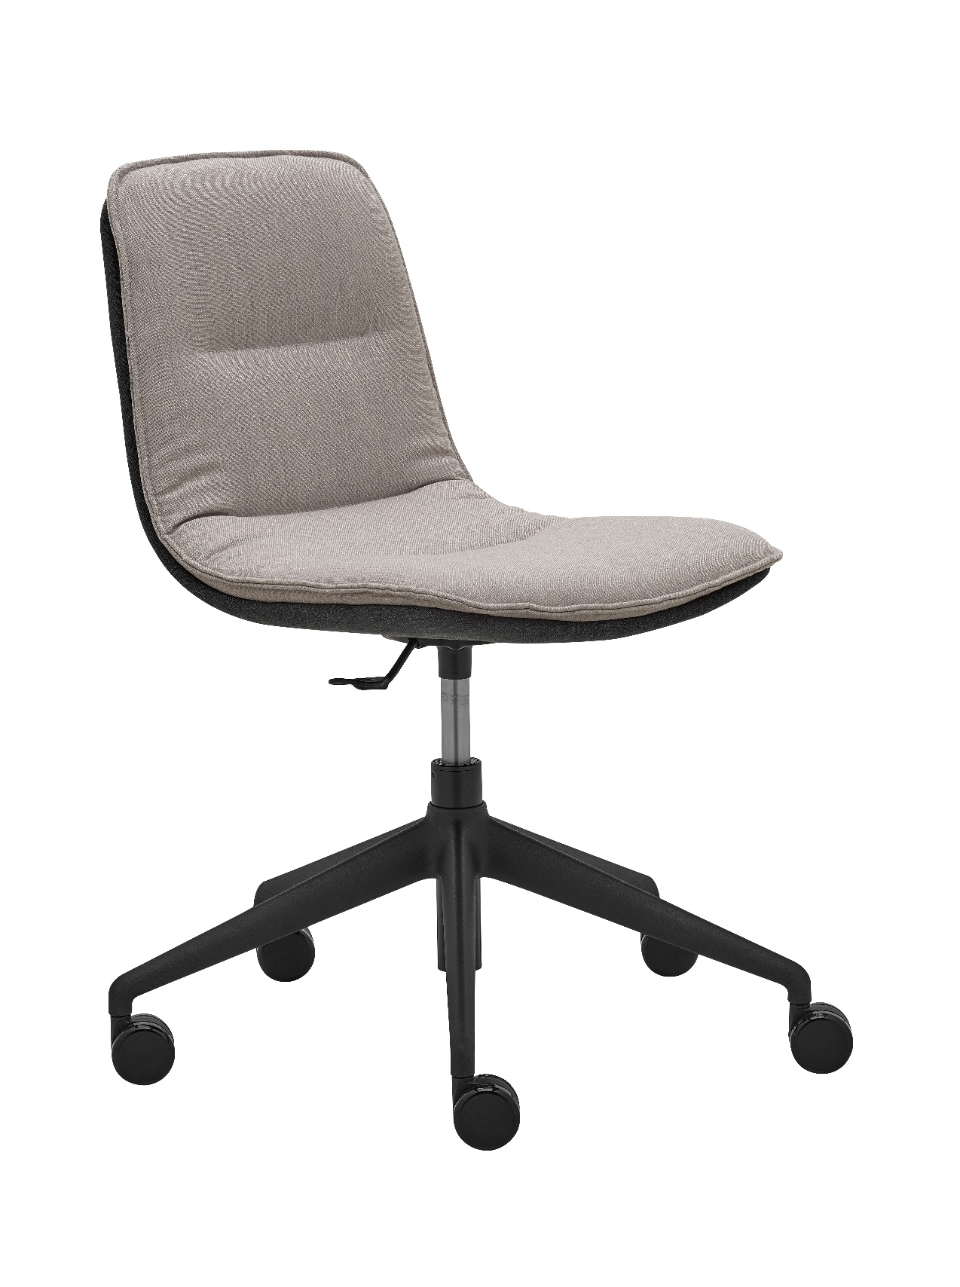

Edge 4201.15 | Design: Kai Stania (AT)  Manufacturer: RIM CZ a. s.
Edge 4201.15

Edge soft chair oscillates between the formal and casual. Distinctive sewing details, lightweight construction, ergonomic shape and an extended selection of base designs suggest large variability of use in different interior settings. Edge collection is thus convenient for conference rooms as well as for relax zones and, last but not least, coffee shops, restaurants and bars.

Description | The shell consists of two parts:  - The rear part is a 3D shaped beech veneer pressed piece of total thickness 10 mm, upholstered from the back with PUR foam of th. 10 mm.  - The front part is a 3D shaped beech veneer pressed piece of total thickness 5 mm, upholstered from the front with an elastic PUR foam of th. 25 mm.
Base | .15 – Swivel mechanism with height-adjustable gas unit and five-star conical base. Base – black plastic, gas unit – black. Extended diameter of the base (700 mm) prevents the armchair from turning over, stability guaranteed.
Castors | Castors Ø 60 mm, braked, for soft and hard floors.
Upholstery | To be selected from fabric collection.
Optional | - Castors – white ring
Warranty | 5 years (see Terms and Conditions)
Dimensions (mm) | 