Edge

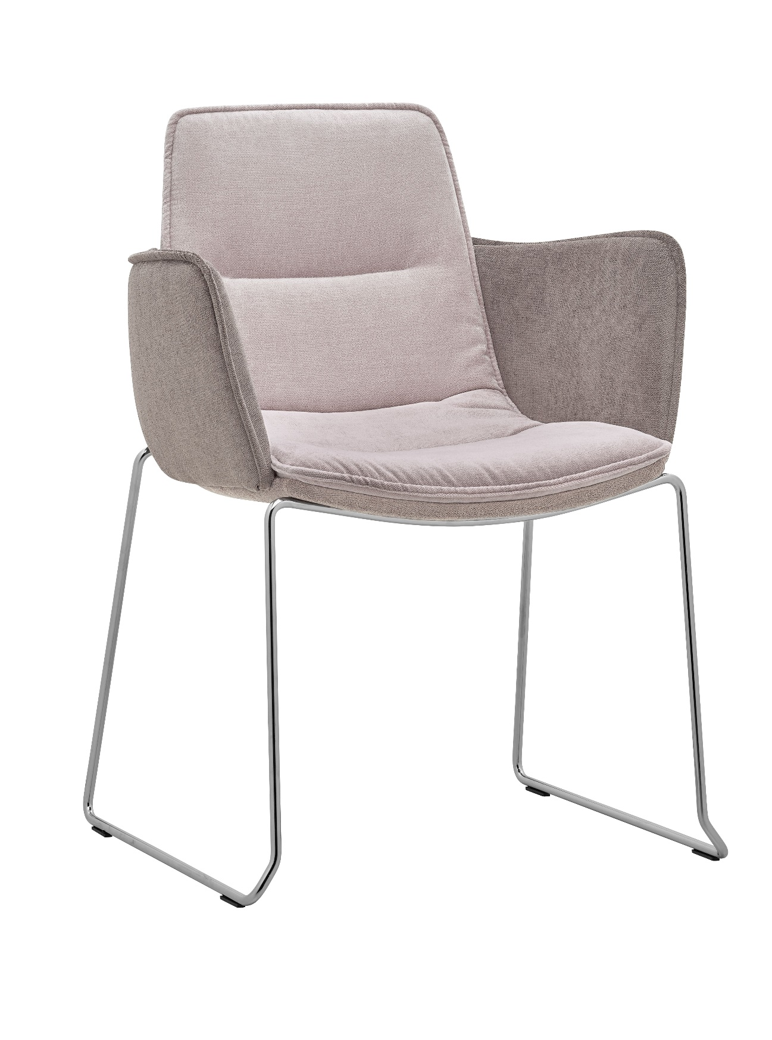

Edge 4202.07 | Design: Kai Stania (AT)  Manufacturer: RIM CZ a. s.
Edge 4202.07

Edge armchair oscillates between the formal and casual. Distinctive sewing details, lightweight construction, ergonomic shape and an extended selection of base designs suggest large variability of use in different interior settings. Edge will thus effortlessly complement a desk for short meetings or coffee shops and lounge zones in various types of public spaces.

Description | The shell consists of two parts:  - The rear part is a 3D shaped beech veneer pressed piece of total thickness 10 mm, upholstered from the back with PUR foam of th. 10 mm.  - The front part is a 3D shaped beech veneer pressed piece of total thickness 5 mm, upholstered from the front with an elastic PUR foam of th. 25 mm.
Armrests | 3D shaped beech veneer pressed piece o total thickness 10 mm, upholstered with PUR foam from both sides
Base | .07 – Structure made of a firm wire (Ø 12 mm), bent in one unit. Finish – chrome or black powder colour spraying as per RAL. Other colours RAL on request. Plastic glides.
Upholstery | To be selected from fabric collection.
Optional | - Plastic glides with felt pad
Warranty | 5 years (see Terms and Conditions)
Dimensions (mm) | 