Winx

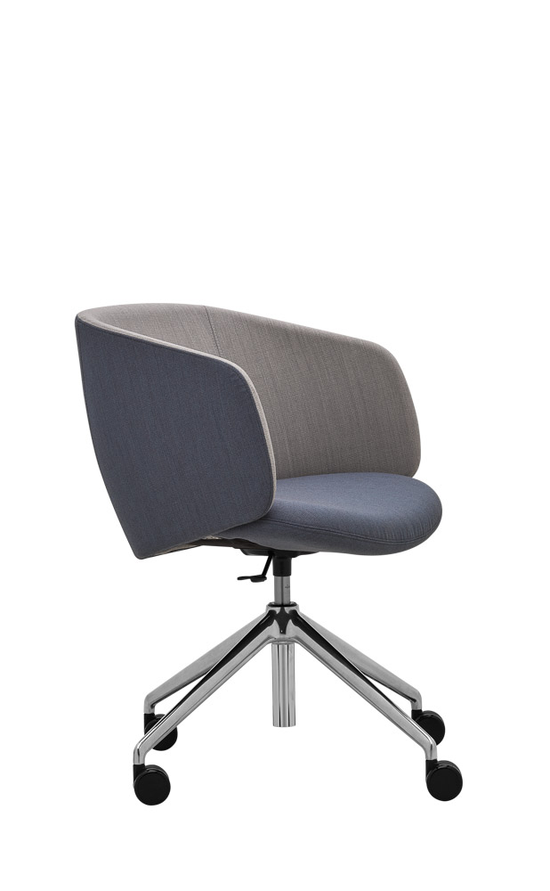

Winx WX 880.04 | Design: Kai Stania (AT)  Manufacturer: RIM CZ a. s.
Winx WX 880.04

Fully-upholstered armchair of contemporary design with integrated armrests, designated for relax zones, home offices, waiting areas, entrance halls and receptions. Precise upholstery, customizable colour and material combination.

Description | The shell consists of two parts:  The seat is a 13-layer beech pressing with a total thickness of 14 mm. Individual veneer thickness is 1,1 mm. Upholstered with PUR foam of thickness 50 mm and volume 70 kg/m3.  The backrest is a separate piece, firmly attached to the seat, consisting of a wire frame filled with PUR foam (volume 70 kg/m3).
Base | .04 – Swivel mechanism with height-adjustable gas unit and four-star aluminium base of conical shape. Base – polished Alu, gas unit – chrome. Extended diameter of the base (700 mm) prevents the armchair from turning over, stability guaranteed.
Castors | Castors Ø 60 mm, braked, for soft and hard floors.
Upholstery | To be selected from fabric collection.
Optional | - Base – other colours RAL – on request  - Castors with a chrome ring for soft and hard floors  - Universal glides for soft and hard floors
Warranty | 5 years (see Terms and Conditions)
Dimensions (mm) | 